Enter the this url putty,
Putty out put give the administrator password place,
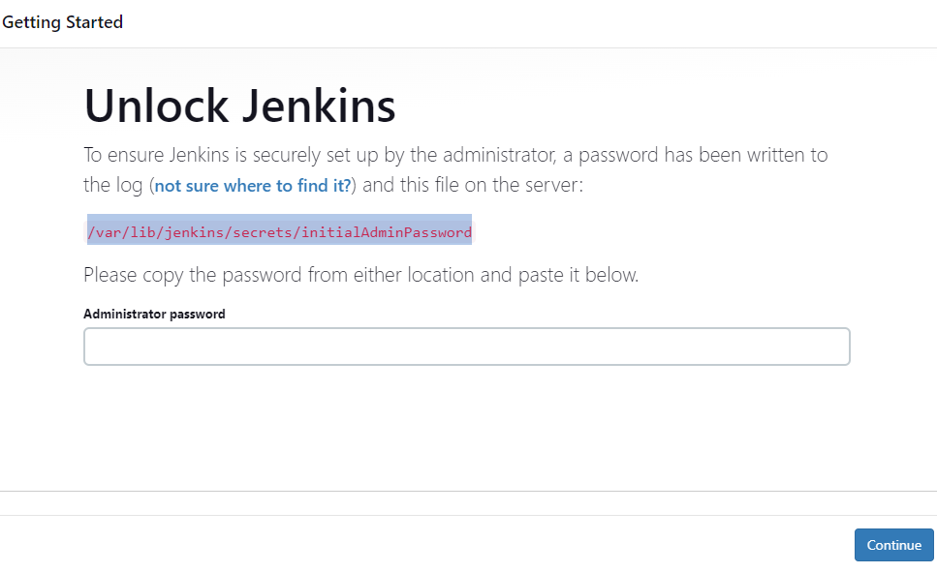

Click on enter icon then screen display the like this,
Click on the install suggested plugins,

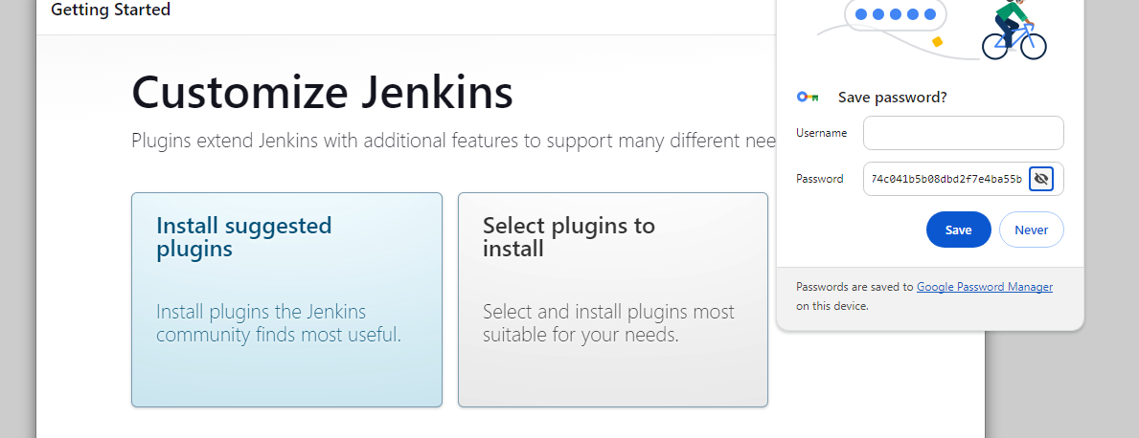

Enter the below details like user name, password, confiram password, full name and e-mail address
Click on save and continue,
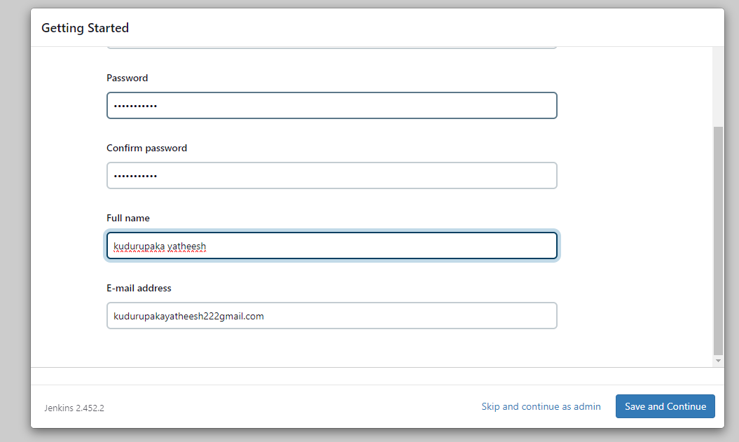
Click on never and continue,

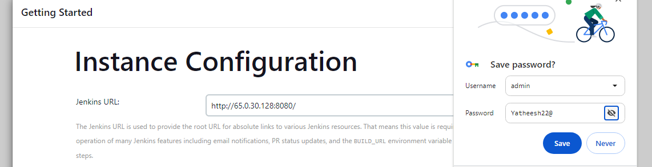

Enter the user name and password click on sign in
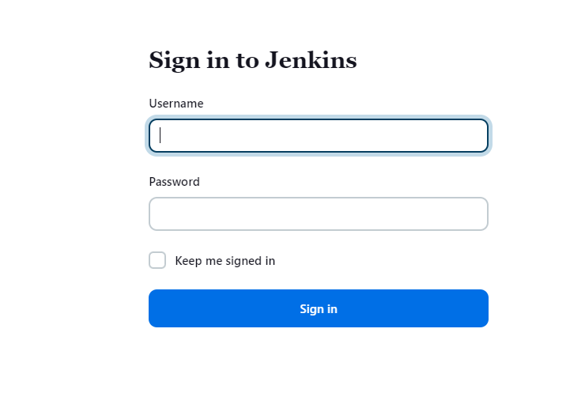

After your enter the user name and password , web page display the like this page,
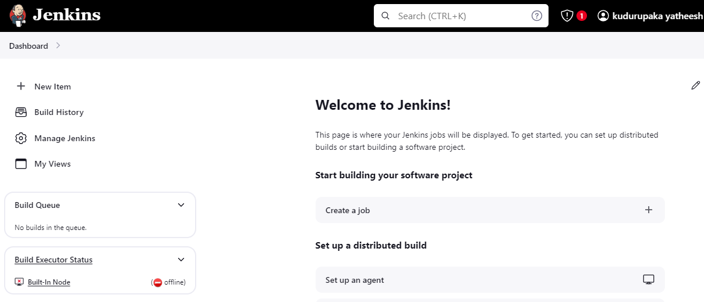

If you want any plugins [plugins means tools]
Navigate to the manage Jenkins here select to the plugins tools, like mvn git tomcat, then click on right said install Icon button,
After installation do the restart the Jenkins,
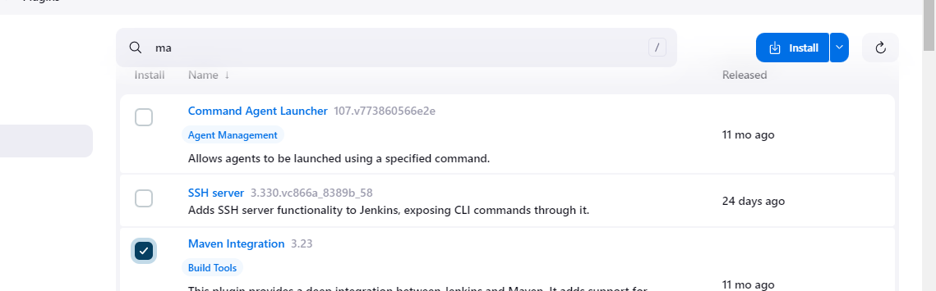

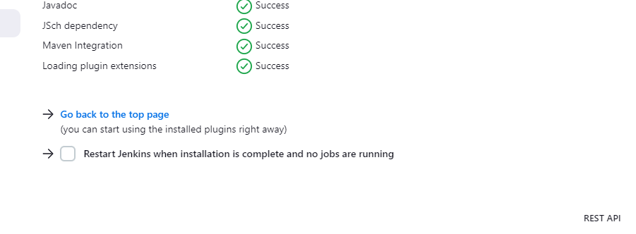

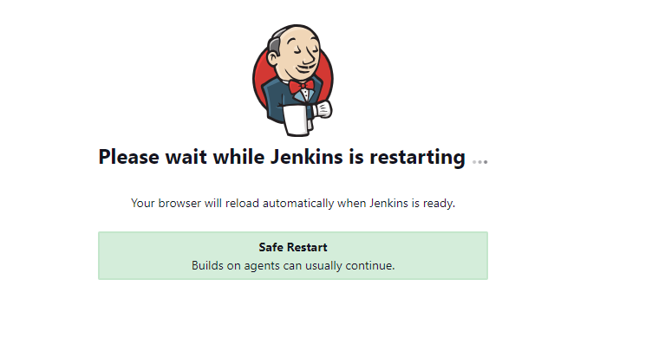
After restart Jenkins show the like this blow page, here enter the user name and password,

Thank
